**Santa Barbara Public Market Evolves with a Local Art Exhibition and New Restaurants**

July 26, 2023

Since purchasing the Santa Barbara Public Market at 38 W Victoria St in December 2021, Travis Twining and the Winn-Twining family have been making moves to help the South Coast’s only food hall reach its potential, with the goal of showcasing local operators as much as possible. Following the addition of Shalhoob’s two locations on premises in 2022, two new restaurants are joining the lineup in 2023, as detailed below. Furthermore, keeping with the theme of showcasing local talent, the Winn-Twining Family is sponsoring a new program to exhibit works by local artists in the Public Market.

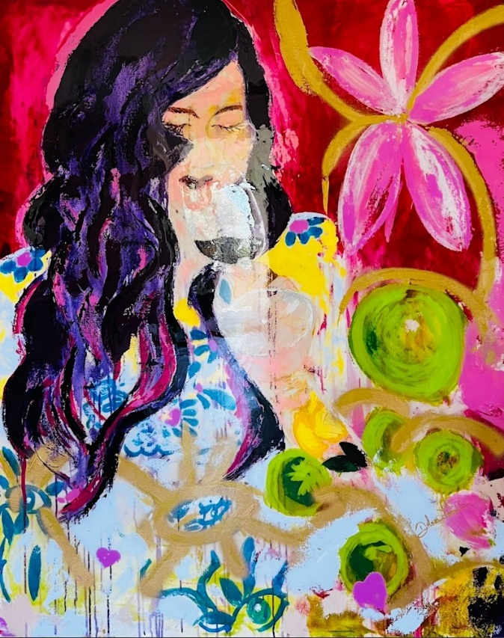

IMMERSE – Delmar León (oil & acrylic 40x60)

**Santa Barbara Public Market Presents: Local Artists**

The Victoria Street corridor is the epicenter of Santa Barbara’s arts & entertainment district, where locals and tourists alike enjoy fine restaurants, live performances, visual art, and boutique shopping.

As long-time residents and patrons of the arts, the Winn-Twining family is currently dedicating space within Santa Barbara Public Market as a showcase for local artists. After an initial trial phase, the intention is to create a permanent exhibition space, for the benefit of both local artists and the community. In that spirit, for the time being at least, no fees/commissions will be burdened upon the artists.

Currently, the Public Market is displaying the works of (in alphabetical order):

* Chadillac - <https://www.instagram.com/chadillac_green_paints/>
* Delmar León - <https://www.delmarleon.com/>
* Johnny Onionseed - <https://www.instagram.com/johnnyonionseed/>
* Kelly Clause - <https://kellyclause.com/>

A variety of artists from up and down the South Coast are being contacted, and there are already artists waiting to be part of the next rotation.

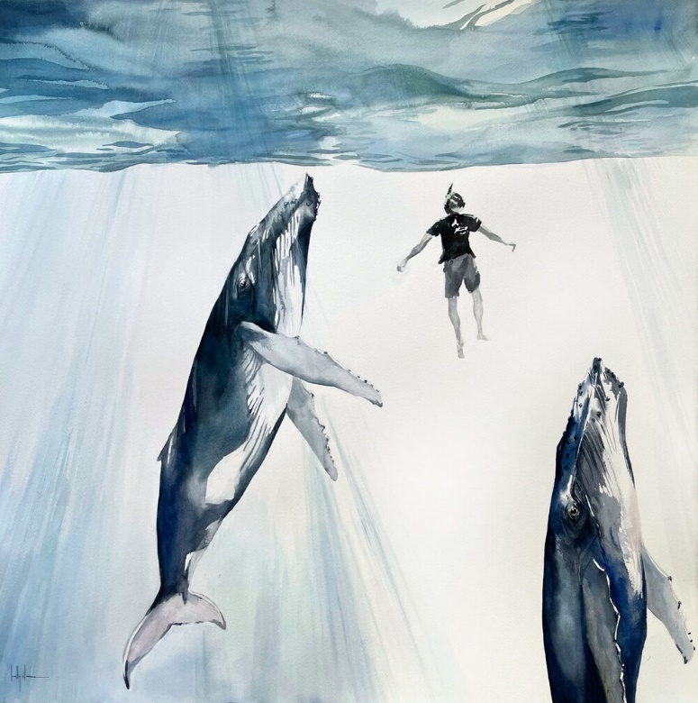

TEMOANA – Kelly Clause (watercolor 39x39)

**Three Monkeys**

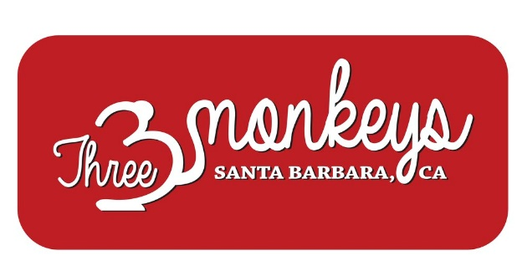

The newest restaurant in the market is [Three Monkeys](http://threemonkeyssb.com/), which opened in April and is the creation of Nui Pannak—the chef/owner of the ever-popular Empty Bowl restaurant in the market. Pannak’s consistently evolving menu at Three Monkeys is inspired by street food favorites from her native Thailand as well as Vietnam. Offerings include an assortment of skewered meats -- chicken satay, Bangkok grilled beef (neua ping) and the Thai-style grilled pork (moo ping). Vietnamese bánh mì is also featured, with choice of pork, beef, chicken, or tofu on a unique baguette custom-baked in the Vietnamese style for Three Monkeys. In addition, there are mouth-watering Pan-fried Thai roti desserts to complete the experience. For more details, see the [review by the Santa Barbara Independent](https://www.independent.com/2023/04/24/street-food-flavor-finds-a-welcome-spot-at-the-santa-barbara-public-market/).

Three Monkeys is open daily from 11 a.m.-2:30 p.m. and 4:30-8:30 p.m.

**Coming Soon: An Authentic Jewish Deli**

“Bringing a top-quality deli to the Market has been part of our plan from the beginning, but we have taken our time finding the right operator,” Travis Twining said. “We are very excited about this new tenant. There’s nothing quite like it the Santa Barbara area, let alone downtown.”

While we are not able to name the deli at this time, an announcement will be coming soon.

For press inquiries, contact [Ted Hoagland](mailto:ted@hayescommercial.com)

For leasing inquiries, contact [Francois DeJohn](mailto:fran@hayescommercial.com)

For Art at Public Market inquiries, contact [Rehman Qadri](mailto:rqadrimsb@gmail.com)